We Serve Through Our Gifts
April 24, 2016
General: $984.00 Building: $65.00
We Serve Through Our Presence
April 24, 2016
Total in Worship: 41 Visitors: 9
We Serve Through Our Service
Monday, May 2, 2016
9:00-3:00 Office Hours
10:30 a.m. Bible Study
12:30 p.m. Woman’s Ministries
5:00 p.m. Katie Jensen’s Wedding Shower
Wednesday, May 4, 2016
9:00-12:00 Office Hours
12:00 p.m. Noon Luncheon
6:30 p.m. Choir
Thursday, May 5, 2016
9:00-5:00 Office Hours
Saturday, May 7, 2016
8:15 a.m. Prayer Breakfast
Sunday, May 8, 2016 Mother’s Day
9:30 a.m. Welcome Center
10:30 a.m. Worship Time
TODAY
Communion

UPCOMING EVENTS
Jensen/Eaton-Williams Wedding
5/14 at 11:00

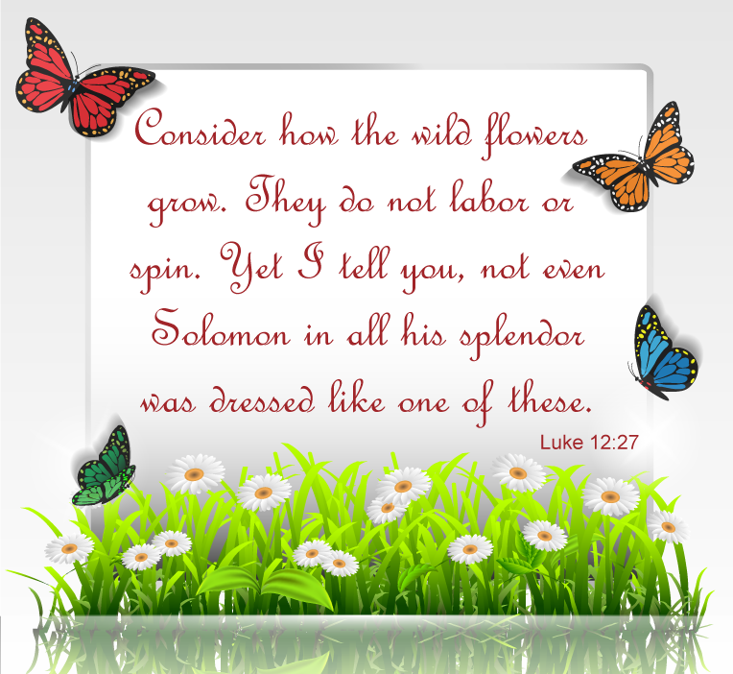

May 1, 2016
OPEN DOORS
United Methodist Church of Blue Eye
6238 E. State Highway 86
Blue Eye, MO 65611 417-779-5677
Jack D. Smith, Pastor
Cell: 417-527-1993/ Home: 417-239-1028
Email: revjack112@msn.com Website:www.blueeyeumc.com
Sunday, May 1, 2016-10:30 a.m.

UMH: United Methodist Hymnal FWS: Faith We Sing songbook
We Gather for Worship
“Forgetting what lies behind and straining forward to what lies ahead, I press on toward the goal for the prize of the upward call of God in Christ Jesus” Phil. 3:13b-14
“This order of worship is subject to change by the Holy Spirit”
*Please stand if you are able
PRELUDE (PREPARING FOR WORSHIP) Janice Settles
WELCOME
Acolyte: Michaela Fransen
BRINGING IN THE LIGHT OF CHRIST

Seek ye first the kingdom of God and his righteousness, and all these things shall be added unto you. Allelu, alleluia! Ask, and it shall be given unto you; seek and ye shall find; knock, and the door shall be opened unto you. Allelu, alleluia!
ANNOUNCEMENTS
OPENING PRAYER (Unison)

O God who is both compassion and power, receive from us this hour all the praise, the thanksgiving, the love we are able to return to You. In the name of Jesus, we pray. Amen.
AFIRMING OUR FAITH

LAY LEADER: Where the Spirit of the Lord is, there is the one true church, apostolic and universal, whose holy faith let us now declare:
ALL: We believe in God the Father, infinite in wisdom, power, and love, whose mercy is over all His works, and whose will is ever directed to His children’s good. We believe in Jesus Christ, Son of God and Son of man, the gift of the Father’s unfailing grace, the ground of our hope, and the promise of our deliverance from sin and death. We believe in the Holy Spirit as the divine presence in our lives, whereby we are kept in perpetual remembrance of the truth of Christ, and find strength and help in time of need. We believe that this faith should manifest itself in the service of love as set forth in the example of our blessed Lord, to the end that the kingdom of God may come upon the earth. Amen.
PROCLAIMING GOD’S WORD

*Gospel Lesson: John 5:1-9
Pages 1653 & 1654 in pew Bible
Lay Leader This is the Word of God for the people of God.
Congregation: Thanks be to God
WORSHIP THROUGH TITHES & OFFERINGS
*DOXOLOGY
Praise God, from whom all blessings flow; praise Him, all creatures here below; praise Him above, ye heavenly host; praise Father, Son, and Holy Ghost. Amen. UMH 95
*OFFERTORY PRAYER
*HYMN OF PREPARATION UMH 513 “Soldiers of Christ, Arise”
PRAISE TIME
Passing God’s Love and Peace, Praise Time in Song
PRAYER TIME
Sharing in Joys and Concerns
Silent Prayer, Pastor’s Prayer, Lord’s Prayer
MESSAGE OF THE DAY Pastor Jack Smith
COMMUNION
*HYMN OF PARTING UMH 467
“Trust and Obey”
(TAKE THE LIGHT OF CHRIST INTO THE WORLD)
*BENEDICTION
POSTLUDE Janice Settle

