We Serve Through Our Gifts
April 10, 2016
General: $1,505.00 Building: $0 Garage Sale: 3,375.00
We Serve Through Our Presence
April 10, 2016
Total in Worship: 33 Visitors: 5
We Serve Through Our Service

Monday, April 18, 2016
9:00-3:00 Office Hours
10:30 a.m. Bible Study
12:30 p.m. Woman’s Ministries
Wednesday, April 20, 2016
9:00-12:00 Office Hours
6:30p.m. Choir
Thursday, April 21, 2016 Movie Night
9:00-5:00 Office Hours
7:00 p.m. “Love’s Long Journey”
Sunday, April 24, 2016
9:30 a.m. Welcome Center
10:30 a.m. Worship Time
11:45 a.m. Potluck
UPCOMING EVENTS
Potluck 4/24
Prayer Breakfast 5/7 8:15

TODAY
Church Council
Blue Sunday

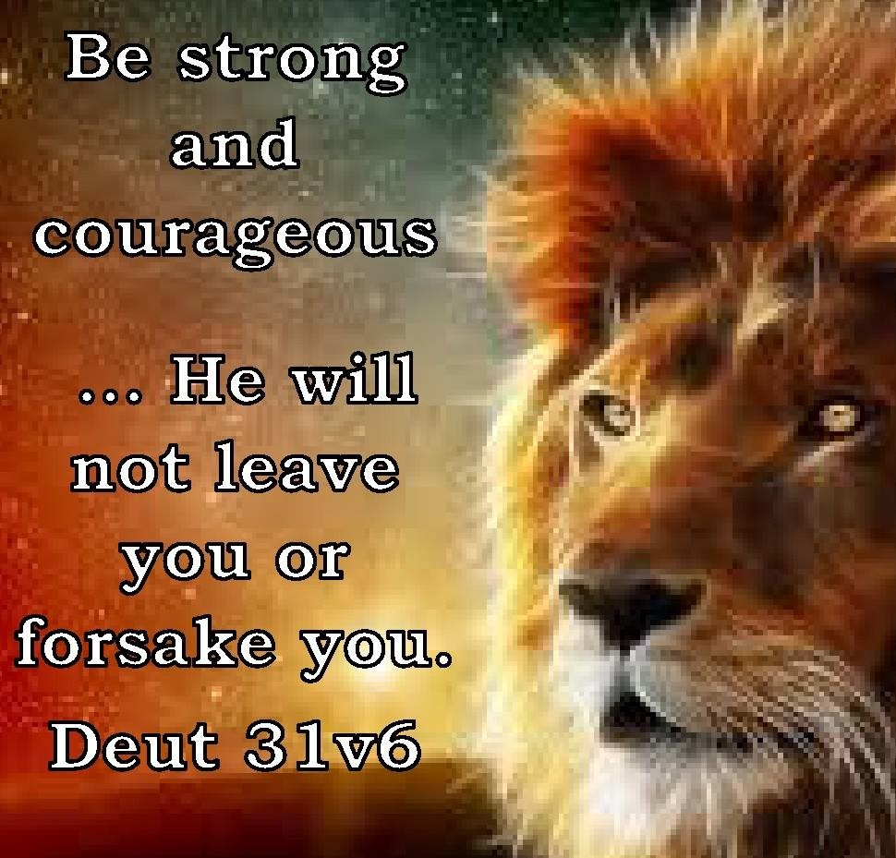

April 17, 2016
OPEN DOORS
United Methodist Church of Blue Eye
6238 E. State Highway 86
Blue Eye, MO 65611 417-779-5677
Jack D. Smith, Pastor
Cell: 417-527-1993/ Home: 417-239-1028
Email: revjack112@msn.com Website:www.blueeyeumc.com
Sunday, April 17, 2016-10:30 a.m.

UMH: United Methodist Hymnal FWS: Faith We Sing songbook
We Gather for Worship
“Forgetting what lies behind and straining forward to what lies ahead, I press on toward the goal for the prize of the upward call of God in Christ Jesus” Phil. 3:13b-14
“This order of worship is subject to change by the Holy Spirit”
*Please stand if you are able
PRELUDE (PREPARING FOR WORSHIP) Janice Settles
WELCOME
Acolyte: Michaela Fransen
BRINGING IN THE LIGHT OF CHRIST

He is Lord, He is Lord! He is risen from the dead and He is Lord! Every knee shall bow, every tongue confess that Jesus Christ is Lord.
ANNOUNCEMENTS
OPENING PRAYER (Unison)

Holy God, make Your presence known to us today. We come to You with our vision so often clouded by our sin. Clear away the mist, through Jesus, that we can catch a glimpse of Your presence here. Help us to behold You as You are, not as we would like You to be. We pray to You, our Lord. Amen.
AFIRMING OUR FAITH

LAY LEADER: Where the Spirit of the Lord is, there is the one true church, apostolic and universal, whose holy faith let us now declare:
ALL: We believe in God the Father, infinite in wisdom, power, and love, whose mercy is over all His works, and whose will is ever directed to His children’s good. We believe in Jesus Christ, Son of God and Son of man, the gift of the Father’s unfailing grace, the ground of our hope, and the promse of our deliverance from sin and death. We believe in the Holy Spirit as the divine presence in our lives, whereby we are kept in perpetual remembrance of the truth of Christ, and find strength and help in time of need. We believe that this faith should manifest itself in the service of love as set forth in the example of our blessed Lord, to the end that the kingdom of God may come upon the earth. Amen.
PROCLAIMING GOD’S WORD

*Gospel Lesson: John 10:22-30
Page 1667 in pew Bible
Lay Leader This is the Word of God for the people of God.
Congregation: Thanks be to God
CHOIR
WORSHIP THROUGH TITHES & OFFERINGS
*DOXOLOGY
Praise God, from whom all blessings flow; praise Him, all creatures here below; praise Him above, ye heavenly host; praise Father, Son, and Holy Ghost. Amen. UMH 95
*OFFERTORY PRAYER
*HYMN OF PREPARATION UMH 73 “O Worship the King”
PRAISE TIME
Passing God’s Love and Peace, Praise Time in Song
PRAYER TIME
Sharing in Joys and Concerns
Silent Prayer, Pastor’s Prayer, Lord’s Prayer
MESSAGE OF THE DAY Pastor Jack Smith
*HYMN OF PARTING UMH 368
“My Hope Is Built”
(TAKE THE LIGHT OF CHRIST INTO THE WORLD)
*BENEDICTION
POSTLUDE Janice Settle

