We Serve Through Our Gifts
February 28, 2016
General: $1,020.00 Building: $40.00
We Serve Through Our Presence
February 28, 2016
Total in Worship: 36 Visitors: 2
We Serve Through Our Service

Monday, March 7, 2016
9:00-3:00 Office Hours
10:30 a.m. Bible Study
12:30 p.m. Woman’s Ministries
Tuesday, March 8, 2016 Movie Night
7:00 p.m. “The Way Home”
Wednesday, March 9, 2016
9:00-12:00 Office Hours
12:00 p.m. Noon Luncheon
6:30p.m. Choir
Thursday, March 10, 2016 9:00-5:00 Office Hours
Sunday, March 13, 2016
9:30 a.m. Welcome Center
10:30 a.m. Worship Time

TODAY
COMMUNION
One Great Hour Of Sharing

UPCOMING EVENTS
Blue Eye Bulldog 5K Run/Walk Dogwood Canyon April 16
9:00 a.m. $20.00

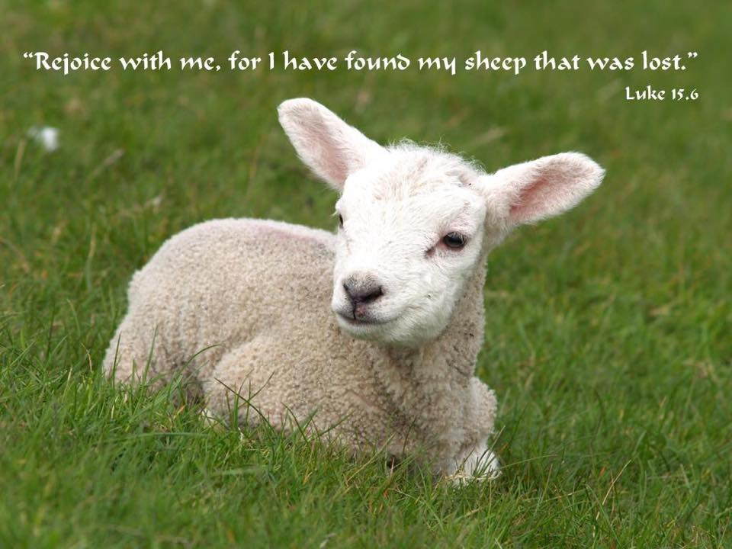

March 6, 2016
OPEN DOORS
United Methodist Church of Blue Eye
6238 E. State Highway 86
Blue Eye, MO 65611 417-779-5677
Jack D. Smith, Pastor
Cell: 417-527-1993/ Home: 417-239-1028
Email: revjack112@msn.com Website:www.blueeyeumc.com

Sunday, March 6, 2016-10:30 a.m.

UMH: United Methodist Hymnal FWS: Faith We Sing songbook
We Gather for Worship
“Forgetting what lies behind and straining forward to what lies ahead, I press on toward the goal for the prize of the upward call of God in Christ Jesus” Phil. 3:13b-14
“This order of worship is subject to change by the Holy Spirit”
*Please stand if you are able
PRELUDE (PREPARING FOR WORSHIP) Janice Settles
WELCOME
Acolyte: Michaela Fransen
*OPENING SONG (BRINGING IN THE LIGHT OF CHRIST)

Jesus, Jesus, Jesus! There’s just something about that name! Master, Savior, Jesus! Like the fragrance after the rain. Jesus, Jesus, Jesus! Let all heaven and earth proclaim; Kings and kingdoms will all pass away, but there’s something about that name!
ANNOUNCEMENTS
OPENING PRAYER (Unison)

O God, our resurrection and life, the promise of Your new life in Christ is like a breath of fresh air in a dry and thirsty land. We have gathered as believers, and as those who are honestly seeking the truth. Guide our worship this hour. Amen.
AFFIRMING OUR FAITH

All: I believe in God the Father Almighty, maker of heaven and earth;
And in Jesus Christ His only Son our Lord: who was conceived by the Holy Spirit, born of the Virgin Mary, suffered under Pontius Pilate, was
crucified, dead, and buried, the third day He rose from the dead; He
ascended into heaven, and sitteth at the right hand of God the Father Almighty; from thence He shall come to judge the quick and the dead.
I believe in the Holy Spirit, the holy catholic church, the communion of saints, the forgiveness of sins, the resurrection of the body, and the life everlasting. Amen.
PROCLAIMING GOD’S WORD

*Gospel Lesson: Luke 15:11b-32
Pages 1624 & 1625 in pew Bible
Lay Leader This is the Word of God for the people of God.
Congregation: Thanks be to God
CHOIR
WORSHIP THROUGH TITHES & OFFERINGS
*DOXOLOGY
Praise God, from whom all blessings flow; praise Him, all creatures here below; praise Him above, ye heavenly host; praise Father, Son, and Holy Ghost. Amen. UMH 95
*OFFERTORY PRAYER
*HYMN OF PREPARATION UMH 420 “Breathe on Me, Breath of God”
PRAISE TIME
Passing God’s Love and Peace, Praise Time in Song
PRAYER TIME
Sharing in Joys and Concerns
Silent Prayer, Pastor’s Prayer, Lord’s Prayer
MESSAGE OF THE DAY Pastor Jack Smith
COMMUNION
*HYMN OF PARTING UMH 365
“Grace Greater than Our Sin”
(TAKE THE LIGHT OF CHRIST INTO THE WORLD)
*BENEDICTION
POSTLUDE Janice Settle

