We Serve Through Our Gifts
March 20, 2016
General: $1,639.00 Building: $140.00
We Serve Through Our Presence
March 20, 2016
Total in Worship: 41 Visitors: 6
We Serve Through Our Service

Monday, March 28, 2016
9:00-3:00 Office Hours
10:30 a.m. Bible Study
12:30 p.m. Woman’s Ministries
Wednesday, March 30, 2016
9:00-12:00 Office Hours
12:00 p.m. Noon Luncheon
6:30p.m. Choir
Thursday, March 31, 2016 9:00-5:00 Office Hours
10:00 a.m. Trustees Meeting
Sunday, April 3, 2016 COMMUNION
9:30 a.m. Welcome Center
10:30 a.m. Worship Time
TODAY

HAPPY EASTER!!

UPCOMING EVENTS
GARAGE SALE
April 7 & 8
Sack Sale
April 9

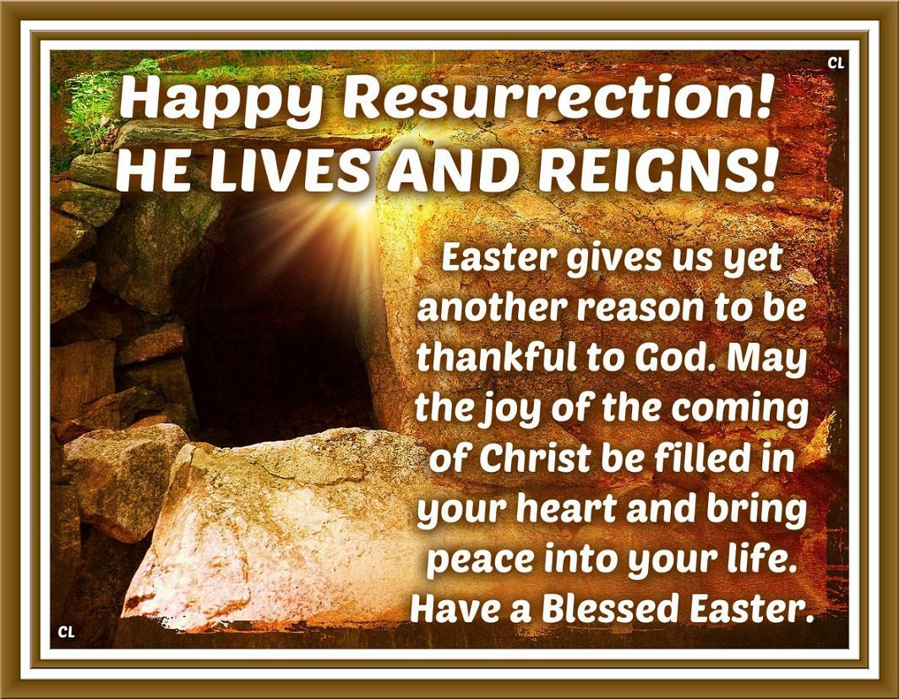

March 27, 2016
OPEN DOORS
United Methodist Church of Blue Eye
6238 E. State Highway 86
Blue Eye, MO 65611 417-779-5677
Jack D. Smith, Pastor
Cell: 417-527-1993/ Home: 417-239-1028
Email: revjack112@msn.com Website:www.blueeyeumc.com

Sunday, March 27, 2016-10:30 a.m.

UMH: United Methodist Hymnal FWS: Faith We Sing songbook
We Gather for Worship
“Forgetting what lies behind and straining forward to what lies ahead, I press on toward the goal for the prize of the upward call of God in Christ Jesus” Phil. 3:13b-14
“This order of worship is subject to change by the Holy Spirit”
*Please stand if you are able
PRELUDE (PREPARING FOR WORSHIP) Janice Settles
WELCOME
Acolyte: Michaela Fransen
*OPENING SONG (BRINGING IN THE LIGHT OF CHRIST)

Jesus, Jesus, Jesus! There’s just something about that name! Master, Savior, Jesus! Like the fragrance after the rain. Jesus, Jesus, Jesus! Let all heaven and earth proclaim; Kings and kingdoms will all pass away, but there’s something about that name!
ANNOUNCEMENTS
OPENING PRAYER (Unison)

O Thou, who makest the stars and turnest the shadow of death into the morning: On this day of days we meet to render thee, our Lord and King, the tribute of our praise: for the resurrection of the springtime, for the everlasting hopes that rise within the human heart, and for the Gospel which has brought life and immortality to light. Receive our thanksgiving, reveal thy presence, and send into our hearts the Spirit of the risen Christ. Amen.
AFFIRMING OUR FAITH

All: I believe in God the Father Almighty, maker of heaven and earth; And in Jesus Christ His only Son our Lord: who was conceived by the Holy Spirit, born of the

Virgin Mary, suffered under Pontius Pilate, was crucified, dead, and buried, the third day He rose from the dead; Heascended into heaven, and sitteth at the right hand of God the Father Almighty; from thence He shall come to judge the quick and the dead. I believe in the Holy Spirit, the holy catholic church, the communion of saints, the forgiveness of sins, the resurrection of the body, and the life everlasting. Amen.
PROCLAIMING GOD’S WORD

*Gospel Lesson: Luke 24:1-12
Page 1642 in pew Bible
Lay Leader This is the Word of God for the people of God.
Congregation: Thanks be to God
CHOIR
WORSHIP THROUGH TITHES & OFFERINGS
*DOXOLOGY
Praise God, from whom all blessings flow; praise Him, all creatures here below; praise Him above, ye heavenly host; praise Father, Son, and Holy Ghost. Amen. UMH 95
*OFFERTORY PRAYER
*HYMN OF PREPARATION UMH 302 “Christ the Lord Is Risen Today”
PRAISE TIME
Passing God’s Love and Peace, Praise Time in Song
PRAYER TIME
Sharing in Joys and Concerns
Silent Prayer, Pastor’s Prayer, Lord’s Prayer
MESSAGE OF THE DAY Pastor Jack Smith
*HYMN OF PARTING UMH 327
“Crown Him with Many Crowns”
(TAKE THE LIGHT OF CHRIST INTO THE WORLD)
*BENEDICTION
POSTLUDE Janice Settle

