We Serve Through Our Gifts
February 7, 2016
General: $2,138.00 Building: $40.00
We Serve Through Our Presence
February 7, 2016
Total in Worship: 37 Visitors: 7
We Serve Through Our Service

Monday, February 15, 2016
9:00-3:00 Office Hours
10:30 a.m. Bible Study
12:30 p.m. Woman’s Ministries
Tuesday, February 16, 2016 Movie Night
7:00 p.m. “Ring The Bell”
Wednesday, February 18, 2016
9:00-12:00 Office Hours
12:00 p.m. Noon Luncheon
6:30p.m. Choir
Thursday, February 19, 2016
9:00-5:00 Office Hours
Sunday, February 21, 2016
9:30 a.m. Welcome Center
10:30 a.m. Worship Time

UPCOMING EVENTS

Movie Nights 2/16 & 2/25

TODAY
HAPPY VALENTINE’S DAY

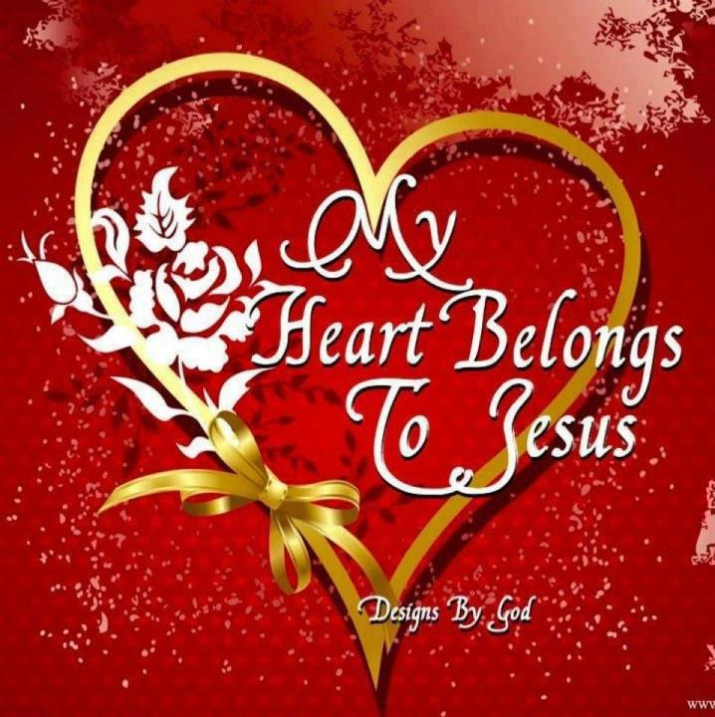

February 14, 2015
OPEN DOORS
United Methodist Church of Blue Eye
6238 E. State Highway 86
Blue Eye, MO 65611 417-779-5677
Jack D. Smith, Pastor
Cell: 417-527-1993/ Home: 417-239-1028
Email: revjack112@msn.com Website:www.blueeyeumc.com
Sunday, February 14, 2016-10:30 a.m.

UMH: United Methodist Hymnal FWS: Faith We Sing songbook
We Gather for Worship
“Forgetting what lies behind and straining forward to what lies ahead, I press on toward the goal for the prize of the upward call of God in Christ Jesus” Phil. 3:13b-14
“This order of worship is subject to change by the Holy Spirit”
*Please stand if you are able
PRELUDE (PREPARING FOR WORSHIP) Janice Settles
WELCOME
Acolyte: Michaela Fransen
*OPENING SONG (BRINGING IN THE LIGHT OF CHRIST)

Into my heart, into my heart, come into my heart, Lord Jesus; come in today, come in to stay; come into my heart, Lord Jesus. Out of my heart, out of my heart, shine out of my heart, Lord Jesus; shine out today, shine out alway; shine out of my heart, Lord Jesus.
ANNOUNCEMENTS
OPENING PRAYER (Unison)

O still, small voice, speak to us this hour, that we might become makers of Your peace in our homes, in our communities, in our world. We pray all this in the name of the One who calmed the raging sea. Amen.
AFFIRMING OUR FAITH

All: I believe in God the Father Almighty, maker of heaven and earth;
And in Jesus Christ His only Son our Lord: who was conceived by the Holy Spirit, born of the Virgin Mary, suffered under Pontius Pilate, was
crucified, dead, and buried, the third day He rose from the dead; He
ascended into heaven, and sitteth at the right hand of God the Father Almighty; from thence He shall come to judge the quick and the dead.
I believe in the Holy Spirit, the holy catholic church, the communion of saints, the forgiveness of sins, the resurrection of the body, and the life everlasting. Amen.
PROCLAIMING GOD’S WORD

*Gospel Lesson: Luke 4:1-13
Pages 1595 & 1596 in pew Bible
Lay Leader This is the Word of God for the people of God.
Congregation: Thanks be to God
CHOIR
WORSHIP THROUGH TITHES & OFFERINGS
*DOXOLOGY Praise God, from whom all blessings flow; praise God, all creatures here below: Alleluia! Alleluia! Praise God, the source of all our gifts! Praise Jesus Christ, whose power uplifts! Praise the Spirit, Holy Spirit! Alleluia! Alleluia! Alleluia! UMH 94
*OFFERTORY PRAYER
*HYMN OF PREPARATION UMH 181
“Ye Servants of God”
PRAISE TIME
Passing God’s Love and Peace, Praise Time in Song
PRAYER TIME
Sharing in Joys and Concerns
Silent Prayer, Pastor’s Prayer, Lord’s Prayer
MESSAGE OF THE DAY Pastor Jack Smith
*HYMN OF PARTING UMH 381
“Savior, Like a Shepherd Lead Us”
(TAKE THE LIGHT OF CHRIST INTO THE WORLD)
*BENEDICTION
POSTLUDE Janice Settles

Human Relations Day
You can give donations today or next week.

