We Serve Through Our Gifts
January 24, 2016
General: $985.00 Building: $0
We Serve Through Our Presence
January 24, 2016
Total in Worship: 32 Visitors: 0
We Serve Through Our Service

Monday, February 1, 2016
9:00-3:00 Office Hours
10:30 a.m. Bible Study
12:30 p.m. Woman’s Ministries
Wednesday, February 3, 2016
9:00-12:00 Office Hours
12:00 p.m. Noon Luncheon
6:30p.m. Choir
Thursday, February 4, 2016
9:00-5:00 Office Hours
Saturday, February 5, 2016
8:15 a.m. Prayer Breakfast
Sunday, February 7, 2016 Communion
9:30 a.m. Welcome Center
10:30 a.m. Worship Time

TODAY
Potluck & Games

UPCOMING EVENTS
Ash Wednesday 2/10
Valentine’s Day 2/14
Movie Nights 2/16 & 2/25

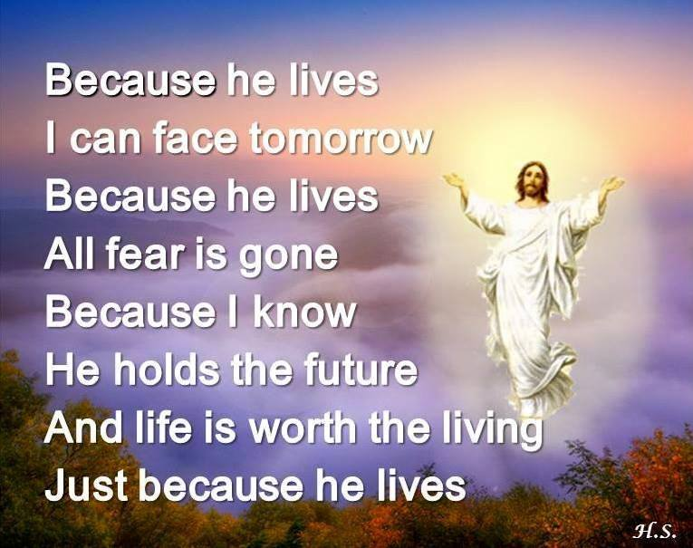
January 31, 2015
OPEN DOORS
United Methodist Church of Blue Eye
6238 E. State Highway 86
Blue Eye, MO 65611 417-779-5677
Jack D. Smith, Pastor
Cell: 417-527-1993/ Home: 417-239-1028
Email: revjack112@msn.com Website:www.blueeyeumc.com
Sunday, January 31, 2016-10:30 a.m.

UMH: United Methodist Hymnal FWS: Faith We Sing songbook
We Gather for Worship
“Forgetting what lies behind and straining forward to what lies ahead, I press on toward the goal for the prize of the upward call of God in Christ Jesus” Phil. 3:13b-14
“This order of worship is subject to change by the Holy Spirit”
*Please stand if you are able
PRELUDE (PREPARING FOR WORSHIP) Janice Settles
WELCOME
Acolyte: Michaela Fransen
*OPENING SONG (BRINGING IN THE LIGHT OF CHRIST)

Our God is an awesome God; He reigns from heaven above with wisdom, pow’r and love. Our God is an awesome God!
ANNOUNCEMENTS
OPENING PRAYER (Unison)

Lord, make us free… free with eyes not focused upon ourselves; free with ears open to hearing Your Word; free with hands reaching out; free with hearts no longer chained by what we possess, but bound, instead, by what we can share. Yes, Lord, make us free… free to worship; free to be extravagant with thankfulness; free to break open the most costly oil upon Your feet; free to love as love really is, In Jesus’ name. Amen.
AFFIRMING OUR FAITH

Lay Leader:This is the good news which we have received, in which we stand, and by which we are saved:
All: Christ died for our sins, was buried, was raised on the third day, and
appeared first to the women, then to Peter and the Twelve, and then to
many faithful witnesses. We believe Jesus is the Christ, the Anointed One of God, the firstborn of all creation, the firstborn from the dead, in whom all things hold together, in whom the fullness of God was pleased to dwell by the power of the Spirit. Christ is the head of the body, the church, and by the blood of the cross reconciles all things to God. Amen.
PROCLAIMING GOD’S WORD

*Gospel Lesson: Luke 4:21-30
Page 1596 in pew Bible
Lay Leader This is the Word of God for the people of God.
Congregation: Thanks be to God
CHOIR
WORSHIP THROUGH TITHES & OFFERINGS
*DOXOLOGY Praise God, from whom all blessings flow; praise God, all creatures here below: Alleluia! Alleluia! Praise God, the source of all our gifts! Praise Jesus Christ, whose power uplifts! Praise the Spirit, Holy Spirit! Alleluia! Alleluia! Alleluia! UMH 94
*OFFERTORY PRAYER
*HYMN OF PREPARATION UMH 444
“O Young and Fearless Prophet”
PRAISE TIME
Passing God’s Love and Peace, Praise Time in Song
PRAYER TIME
Sharing in Joys and Concerns
Silent Prayer, Pastor’s Prayer, Lord’s Prayer
MESSAGE OF THE DAY Pastor Jack Smith
*HYMN OF PARTING UMH 600
“Wonderful Words of Life”
(TAKE THE LIGHT OF CHRIST INTO THE WORLD)
*BENEDICTION
POSTLUDE Janice Settles

