We Serve Through Our Gifts
January 17, 2016
General: $765.00 Building: $0
We Serve Through Our Presence
January 17, 2016
Total in Worship: 32 Visitors: 2
We Serve Through Our Service

Monday, January 25, 2016
9:00-3:00 Office Hours
10:30 a.m. Bible Study
12:30 p.m. Woman’s Ministries
Wednesday, January 27, 2016
9:00-12:00 Office Hours
12:00 p.m. Noon Luncheon
6:30p.m. Choir
Thursday, January 28, 2016 Movie Night
9:00-5:00 Office Hours
7:00 p.m. Christmas Blessing
Sunday, January 31, 2016
9:30 a.m. Welcome Center
10:30 a.m. Worship Time
11:45 a.m. Potluck
12:30 p.m. Games

UPCOMING EVENTS
Potluck & Games Day 1/31
Ash Wednesday 2/10

TODAY
Church Council

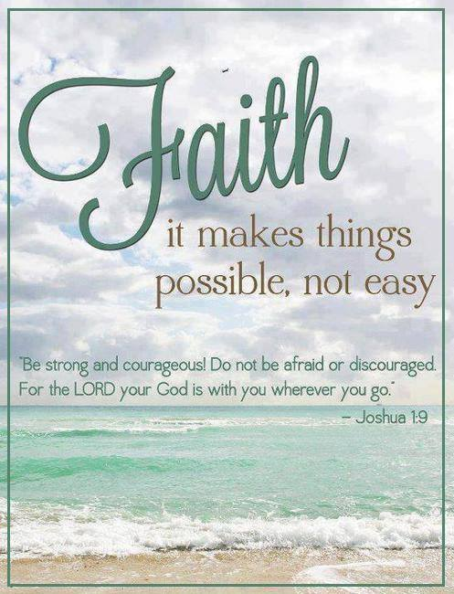
January 24, 2015
OPEN DOORS
United Methodist Church of Blue Eye
6238 E. State Highway 86
Blue Eye, MO 65611 417-779-5677
Jack D. Smith, Pastor
Cell: 417-527-1993/ Home: 417-239-1028
Email: revjack112@msn.com Website:www.blueeyeumc.com
Sunday, January 24, 2016-10:30 a.m.

UMH: United Methodist Hymnal FWS: Faith We Sing songbook
We Gather for Worship
“Forgetting what lies behind and straining forward to what lies ahead, I press on toward the goal for the prize of the upward call of God in Christ Jesus” Phil. 3:13b-14
“This order of worship is subject to change by the Holy Spirit”
*Please stand if you are able
PRELUDE (PREPARING FOR WORSHIP) Janice Settles
WELCOME
Acolyte: Michaela Fransen
*OPENING SONG (BRINGING IN THE LIGHT OF CHRIST)

Our God is an awesome God; He reigns from heaven above with wisdom, pow’r and love. Our God is an awesome God!
ANNOUNCEMENTS
OPENING PRAYER (Unison)

O God who is greater than the most powerful forces in this world, enable us to be still and know that You are God, who answers out of the whirlwind of everyday life. Breathe in us Your Holy Spirit to strengthen, comfort, and guide us in the midst of the storm. Amen.
AFFIRMING OUR FAITH

Lay Leader:This is the good news which we have received, in which we stand, and by which we are saved:
All: Christ died for our sins, was buried, was raised on the third day, and
appeared first to the women, then to Peter and the Twelve, and then to
many faithful witnesses. We believe Jesus is the Christ, the Anointed One of God, the firstborn of all creation, the firstborn from the dead, in whom all things hold together, in whom the fullness of God was pleased to dwell by the power of the Spirit. Christ is the head of the body, the church, and by the blood of the cross reconciles all things to God. Amen.
PROCLAIMING GOD’S WORD

*Gospel Lesson: Luke 4:14-21
Page 1596 in pew Bible
Lay Leader This is the Word of God for the people of God.
Congregation: Thanks be to God
CHOIR
WORSHIP THROUGH TITHES & OFFERINGS
*DOXOLOGY Praise God, from whom all blessings flow; praise God, all creatures here below: Alleluia! Alleluia! Praise God, the source of all our gifts! Praise Jesus Christ, whose power uplifts! Praise the Spirit, Holy Spirit! Alleluia! Alleluia! Alleluia! UMH 94
*OFFERTORY PRAYER
*HYMN OF PREPARATION UMH 172
“My Jesus, I Love Thee”
PRAISE TIME
Passing God’s Love and Peace, Praise Time in Song
PRAYER TIME
Sharing in Joys and Concerns
Silent Prayer, Pastor’s Prayer, Lord’s Prayer
MESSAGE OF THE DAY Pastor Jack Smith
*HYMN OF PARTING UMH 368
“My Hope Is Built”
(TAKE THE LIGHT OF CHRIST INTO THE WORLD)
*BENEDICTION
POSTLUDE Janice Settles

