OPEN DOORS UNITED METHODIST CHURCH
OF BLUE EYE
EASTER SONRISE SERVICE
Sunday, March 27, 2016
8:30 A.M.

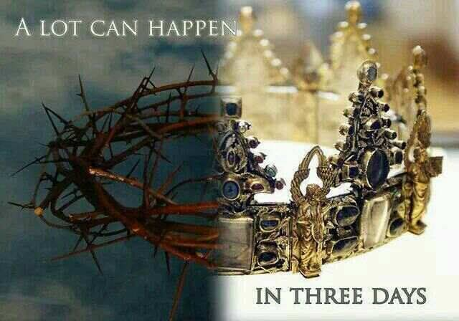

6238 E State HWY 86
Blue Eye, MO 65616
417-779-5677

EASTER SONRISE SERVICE
March 27, 2016

PRELUDE Janice Settles
WELCOME
OPENING Pastor: Jesus Christ Has Risen
People: He Has Risen Indeed!

OPENING PRAYER (Unison)
Almighty God, who hast brought again from the dead our Lord Jesus, the glorious Prince of Peace: Grant us power, we beseech thee, to rise with him to newness of life, that we may overcome the world with the wisdom of faith, and have part at last in the resurrection of the just. Amen.

OPENING SONG FWS 2108
“O How He Loves You and Me”
SCRIPTURE --Mark 16:1-8

AN EASTER AFFIRMATION
Pastor: There was darkness over the earth before creation;
People: There is darkness before birth;
Pastor: The seed grows in darkness before it
meets the light;
People: There is darkness in the tomb before resurrection.
Pastor: But now Christ is risen!
People: The dawn has come
Pastor: A new creation has commenced
People: The world is born anew.
Pastor: Christ is Risen.
People: HE IS RISEN INDEED!
Pastor: Thanks be to God!
People: Alleluia! Alleluia! Amen!
SONG OF PRAISE UMH 322
“Up from the Grave He Arose”
PRAYER OF THANKSGIVING
Pastor: On this day we overflow with thanks and praise, O God, for this is the day you have made, the day that fills us with both fear and great joy.
People: On this day you sent your angels to roll back this stone and you raised Jesus, who had been crucified, from the dead.
Pastor: Never again need we search for Jesus in the places of dead memories and buried dreams, for now he has been raised and goes forever ahead of us to open the gates of justice, preaching peace and the forgiveness of sins.
People: Indeed though he was the stone rejected by the builders, you have made him the cornerstone, the rock on which is founded the life everlasting, the life that is hidden for us in Christ until it is revealed with Christ in glory.
Pastor: We thank you and we praise you O God, both now, and through your living word, eternally.
People: Amen
SONGS OF PRAISE
“In the Garden” UMH 314
“Jesus, Name above All Names” FWS 2071
“I Love You, Lord” FWS 2068

MESSAGE Pastor Jack Smith

SONG OF CLOSING UMH 318
“Christ Is Alive”
CLOSING PRAYER
BENEDICTION
POSTLUDE Janice Settles

