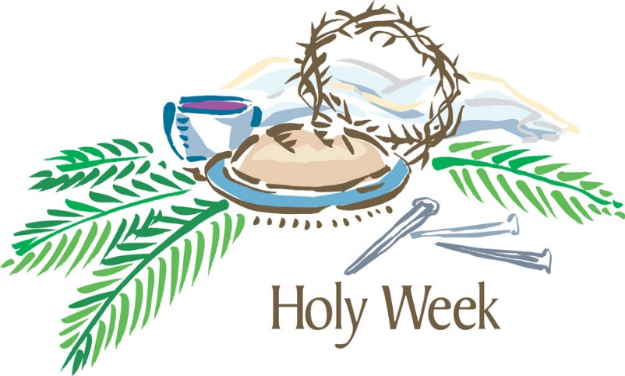

OPEN DOORS UNITED METHODIST CHURCH OF BLUE EYE
March 24, 2016
7:00 P.M.

6238 E State HWY 86
Blue Eye, MO 65611
417-779-5677

Maundy Thursday
Communion Service
March 24, 2016

PRELUDE Janice Settles
WELCOME

OPENING HYMN- “Were You there” UMH 288 Verses 1, 3 & 5
CALL TO WORSHIP
Pastor: This is the day that Christ the Lamb of God gave Himself into the hands of those who would slay Him.
People: This is the day that Christ gathered with His disciples in the upper room.
Pastor: This is the day that Christ took a towel and washed the disciples’ feet, giving us an example that we should do to others as He has done to us.
People: This is the day that Christ our God gave us the holy feast, that we who eat this bread and drink this cup may here proclaim His holy sacrifice, and be partakers of His resurrection, and at the last day may reign with Him in heaven.

INVOCATION
Almighty Father, whose dear Son, on the night before He suffered, did institute the Sacrament of His body and blood: Mercifully grant that we may thankfully receive the same in remembrance of Him, who in these holy mysteries giveth us a pledge of life eternal; the same thy Son Jesus Christ our Lord, who now liveth and reigneth with thee and the Holy Spirit ever, one God, world without end. Amen.
SCRIPTURE LESSON- John 13:1-17, 31b-35
Pages 1673-1675

CHOIR

PRAYER OF CONFESSION
Pastor: O God, in this hour of solemn remembrance we acknowledge with sorrow and shame that our sins are such as sent our blessed Lord to the cross.
People: Lord, have mercy upon us.
Pastor: We confess with penitence that we have been slow to accept that forgiveness of sins and cleansing from all unrighteousness which by his death he sealed for us as the free gift of God.
People: Lord, have mercy upon us.
Pastor: We have not always entered into the fellowship of sufferings, and have charged thee with indifference to sorrow and pain.
People: Lord, have mercy upon us.

WORDS OF FORGIVENESS

LORD’S PRAYER
HYMN- “Go to Dark Gethsemane UMH 290

MESSAGE Pastor Jack Smith
SPECIAL MUSIC

LAST SUPPER-HOLY COMMUNION UMH 15
CLOSING PRAYER
CLOSING HYMN- “What Wondrous Love Is This” UMH 292

BENEDICTION
POSTLUDE Janice Settles

